

9B17M139

CURANA: MANAGING OPEN INNOVATION FOR GROWTH IN SMES (A)

Wim Vanhaverbeke wrote this case solely to provide material for class discussion. The author does not intend to illustrate either effective or ineffective handling of a managerial situation. The authors may have disguised certain names and other identifying information to protect confidentiality.

*This publication may not be transmitted, photocopied, digitized, or otherwise reproduced in any form or by any means without the permission of the copyright holder. Reproduction of this material is not covered under authorization by any reproduction rights organization. To order copies or request permission to reproduce materials, contact Ivey Publishing, Ivey Business School, Western University, London, Ontario, Canada, N6G 0N1; (t) 519.661.3208; (e)* [*cases@ivey.ca*](mailto:cases@ivey.ca)*;* [*www.iveycases.com*](http://www.iveycases.com)*.*

Copyright © 2017, Richard Ivey School of Business Foundation Version: 2017-08-31

It was a sunny day in June 2009, and Dirk Vens, chief executive officer of Curana BVBA (Curana), had just returned to his office after a lively meeting with a potential customer. The customer was very interested in Curana’s innovative bicycle accessories: and he was not the only one. Curana, a small, Belgian, family-owned bicycle parts producer, had changed its strategy completely at the turn of the century and was becoming increasingly popular as a preferred strategic development partner for leading European bicycle manufacturers.

Following the change of direction, revenues had quadrupled in just six years’ time. The company was in good financial health, but Vens was not lulled by the success. He was concerned with sustaining such growth. In his view, revenues could still increase substantially in the coming years without any business model changes, but the first signs of limits on growth were appearing and a change in strategy was needed.

To make this move, Vens had different options, some implying a considerable departure from the current highly successful strategy. He needed a structured plan; the board meeting was scheduled within weeks.

COMPANY HISTORY AND INDUSTRY LANDSCAPE

Curana was a third generation family business located in Roeselare, Belgium. Even after a decade of growth, the company did not have more than 12 employees. The company was co-owned by Vens and his brother Geert, who was the chief operating officer. The brothers had taken over the business from their parents in 1990.

The brothers’ grandfather had started Curana as a bicycle shop in the 1940s. The shop also produced bicycle frames, which was uncommon for a bicycle retailer. At the time, most shops purchased accessories from preferred original equipment manufacturers (OEM) and assembled the bicycles; they were not involved in production. Curana continued to stand out after World War II, manufacturing their own bicycle accessories in addition to the frames.

The next generation took over Curana in the 1960s; the founder’s daughter, Erika, entered the business with her husband. Unlike the founder, the couple approached the market conservatively. During those years, there was almost no product development and Curana worked as an OEM of bicycle accessories such as luggage carriers and mudguards. In essence, Curana was responding to the requirements of the customers.

Between the 1960s and 1980s, the market evolved, and with it, bicycle retailers’ strategy. The shift from a highly competitive market (40–50 competitors) to an oligopolistic market left many out of the business. By the 1980s, only a few accessory suppliers survived. These companies all struggled with pricing pressure from the bicycle manufacturers. The 1980s was also a time when the bicycle business was still nationally structured. There was a typical Belgian bike, a typical Dutch one, and so on, and every country had its own local suppliers. As a result of the shifts and continuing pressures on price, bike accessory manufacturers either exited the market, one by one, or were acquired by the remaining competitors. By the 1990s, Curana was nearly the sole surviving accessory manufacturer on the Belgian market.

Vens and Geert took over the company at the dawn of a major change in the business landscape: mountain bikes were becoming fashionable and new segments of other sport bikes were being developed. Bicycling also became more popular in Europe, notably in Belgium and the Netherlands. Additionally, raw materials for production were increasingly changing to plastics and other inexpensive materials.

In the wake of these trends, the bicycle industry was rapidly internationalizing. Mountain bikes, for example, were produced on a global scale, and European bicycle manufacturers started sourcing internationally for cheaper accessories. Imports from Taiwan, in particular, were growing at a tremendous speed. As a result, finished bikes were imported at lower cost and garmented with all possible frills: overcoat guards*,* mudguards*,* luggage carriers, chain fenders, and so on. Most European bicycle parts producers could not withstand this lethal competitive pressure. With the change in raw materials, mudguards, for instance, were no longer made only from steel but also from aluminum and polypropylene. Curana thus faced increasing competition in the 1990s from companies that flooded the market with plastic mudguards.

Looking back on the situation, Vens commented:

The market conditions in the second half of the 1990s were deteriorating rapidly. We had no other option than to change strategy drastically. . . . We had always been a production-driven bicycle parts manufacturer, producing fenders and racks according to the specs of our customers. In 1999, we decided to become a product-driven company with a strong emphasis on design and innovation. We decided to conceive, develop, and produce products that were completely new for the industry.

In pursuit of its new innovation strategy, Curana focused on mudguards. Since plastic mudguards had some advantages over those made from steel and aluminum,[1] management focused on designing and producing plastic mudguards quickly. The company was not interested in copying or improving existing bicycle accessories, however. “This would bring us back into the logic of a price competition, which you only can win through gigantic investments in manufacturing equipment,” Vens commented.

Instead, Curana opted for innovation. Vens explained, “We wanted to develop concepts that were new not only for Curana, but also for the industry, so that we would be the only one to offer them on the market. In this way, we could set our prices and would not suffer from price competition.” Vens realized, however, that the company was not prepared for this new challenge. Curana had never been involved in design and innovation activities. That was about to change.

DEVELOPING THE B"LITE MUDGUARD

Curana commenced its first major design project in December 1998. To begin, Vens contacted Pilipili, a neighbouring design company, to develop new types of plastic mudguards. He was convinced such products could meaningfully differentiate Curana from established competitors. The design cost (set at €30,000[2]) was a high price for a small company, but the deal went through nevertheless. Sadly, the project ended without any tangible result.

Not ready to give up, Vens continued his search for collaborators. He met a designer at Batavus, a Dutch bicycle manufacturer and one of Curana’s main clients. The designer provided feedback on the newly designed plastic mudguard. He was skeptical about the quality and look of the new ideas; moreover, he felt the concept lacked the hi-tech look needed to shake up the bicycle parts industry. The designer further suggested that Curana have a look at the market of garden chairs, where plastic products represented the low-end segments, while chairs that integrated metal and plastic represented the top. Metal, in fact, was used to give a chair its strength, whereas the plastic parts were responsible for the distinguishing look. This conversation encouraged Vens to think about a mudguard that combined both materials.

Taking the idea further, Curana collaborated once again with Pilipili. In doing so, Curana again invested a substantial amount of money in design and development of an innovative mudguard. But additional development issues soon emerged; for example, the new mudguard had a sleek look on the drawing board but the industrial designers faced insurmountable technological problems to produce it. Metal and plastic could not be integrated easily unless glue was used. Hence, a glue manufacturer was consulted, but it turned out that using glue would add additional production steps and, as a consequence, the mudguard could not be sold at a competitive price.

One possible alternative for aluminum and steel was a special sandwich material composed of two thin aluminum layers separated by a layer of polypropylene. This composition made the material lightweight and stiff. Corus, the producer of the sandwich material, encouraged Curana to consider how to maximize the material’s value because the material was too expensive to use in average-priced mudguards. This observation challenged Pilipili and Curana to maximize the benefits for the bicycle manufacturer who would use this type of mudguard.

Ultimately, the development of the B"Lite succeeded: a mudguard with a clean, hi-tech look that combined a shiny aluminum strip with coloured plastic (see Exhibit 1). Installation of the mudguard was done through intelligent clicking systems, and the aluminum separated by the layer of polypropylene could be used as conductors of electricity, eliminating the need to use wires for the lights on the bike. In addition, use of the lightweight composite sandwich material made the mudguard very stiff and 25 per cent lighter than its plastic counterparts.

PRESENTING THE REVOLUTIONARY CONCEPT

Curana’s management presented the B"Lite concept to the Accell Group, headquartered in Heerenveen, Netherlands. The group included bicycle manufacturers such as Batavus, Sparta, Redline, Haibike, Hercules, Koga Miyata, Mercier, and others. Interest soon began to surge. Managers of the Accell Group, in particular, were very enthusiastic about the B"Lite.

Soon, both parties signed a deal. The Accell Group would buy a large volume of the B"Lite under two conditions: a two-year product exclusivity, and proof that Curana could manufacture the new mudguard before May 2001. May was the month in which bicycle manufacturers presented their bike collections for the coming year.

Making the deadline could result in huge revenue growth for Curana, but taking the B"Lite from a prototype to production presented a challenge. Most injection-moulding companies were skeptical; nobody had manufactured something like this before, so the process needed to be invented. However, a managing director of one of these injection-moulding companies found the idea to be a good challenge and so collaborated with Curana. Vens and the managing director believed in the product; they also had a strong personal relationship. Reflecting on the issue, Vens remembered, “If you don’t have any partners [who] are believers, you’re nowhere. You have to share the passion to succeed in these ventures. Failure is no option.”

However, in 2001, the manager left the injection-moulding company and Vens was left with a team that was skeptical about the project. The innovation process was riddled with problems, and ultimately Curana did not meet the May 2001 deadline. The Accell Group extended the deadline to April 2002, but once again, the process proved slow. “The people in the partnering company that supported our idea departed. The others didn’t believe in it at all. It wasn’t an easy time. For Curana, it was an expensive venture and we really balanced on the financial edge,” Vens commented.

When the last injection-moulding company failed to come up with satisfactory results, Vens took action. He contacted an engineer at Vlaams Kunststofcentrum (VKC),[3] a research and development centre that specialized in solving technical processing problems. At first, the managers of the injection-moulding company refused to co-operate with the VKC engineer—they dreaded “intruders.” Vens addressed the cultural differences and within days, the job was done.

The tests then needed to be done, and quickly, but tensions were rising. The injection-moulding company promised the next test in May, too late for Curana’s deadline. Vens felt this was a dead end and contacted Anziplast, another injection-moulding company, to do the work. Vens recalled, “The managing director fully embraced the challenge and the company worked day and night. On April 18th, we [were able to] show the results to the Accell Group.”

The B"Lite was the first major success for Curana. Within six years of its introduction, the company’s turnover quadrupled, and Anziplast’s growth accelerated too. This result prompted Curana’s management to introduce other mudguards with a hi-tech look and accessories. Curana brought the equally successful C"Lite and D"Vide mudguards to market (see Exhibit 1). For accessories, Curana experimented with chain fenders, overcoat guards, and luggage racks. Customers started to realize that Curana was an important partner for their own success. Vens recalled, “Because we were able to develop and produce the B"Lite, customers became confident that we were also able to realize other challenging ideas that could differentiate their bikes from the competition.”

TURNAROUND THROUGH STRATEGIC INNOVATION

No doubt, the development and production of the B"Lite was critical for Curana’s turnaround. It was a marked departure from the old business model: the company was no longer focused on its production, but had redefined itself as a product-driven company focused on designing and manufacturing entirely new products that could differentiate Curana from its competitors. Design and innovation became Curana’s core activity for delivering new products and gaining market share. Curana’s management was determined to further fine-tune this new strategic direction.

The new innovation strategy was focused on offense. Curana positioned itself as a developer of new concepts using new materials that added value for the bicycle manufacturers, dealers, and consumers. The offensive approach also meant that Curana refused to copy or improve existing products on the market. The company insisted on inventing, developing, and producing extraordinary bike parts that were truly new for the industry. Curana’s management called it “bike jewellery.” Vens explained:

We wanted to be recognized in the industry as the supplier of innovative bike accessories. Continuous differentiation became key. Over the years, we evolved from a supplier of products to a developer of innovative solutions. We were constantly looking for far-reaching innovations without waiting for demands from the customers, but we carefully listened to their feedback during the design process.

By 2008, Curana had become a strategic development partner for the big European bicycle manufacturers and was closely involved in their product innovations.

Before 1999: Original Equipment Manufacturer

According to Curana’s management, the company had been through three strategic changes since 1999. Before 1999, Curana was an OEM selling bicycle accessories to several European manufacturers. As the bicycle market became increasingly global and cheap plastic parts replaced steel, accessory manufacturers competed on price. Hence, bicycle parts were not considered vital or value-adding.

1999–2006: Original Design Manufacturer

Following its decision in 1999 to focus on design and innovation (and develop a mudguard that combined plastic and metal), Curana switched to an original design manufacturer strategy. In this role, Curana designed and manufactured products for specific bicycle manufacturers. Curana then added value for its customers through innovative design and the manufacturing of products that were new to the industry. Curana was selling a new product to a single customer: each bicycle manufacturer purchased a distinct concept from Curana so the manufacturer could differentiate from its competitors. The company also set prices, determining its own margins.

2006–2008: Original Strategic Management

Over the years, Curana further fine-tuned its business strategy. In 2006, it established its internal design office; design had, after all, become the heart of the company. Curana thus gradually moved toward an original strategic management role. In order to repeatedly develop new ideas, Curana continuously explored trends, global changes, fashion, new materials, technology, and design with its innovation partners. For that purpose, Curana was strongly involved in design communities and innovation centres, while its management and designers gave guest lectures about their experiences with design, open innovation, and intellectual property management.

Curana thus started with a vision of new opportunities derived from global trends, new materials, and technology breakthroughs. The company offered proactive design solutions. Vens explained:

We finalize ideas up to a certain level and offer them to potential clients. The moment the market picks up the idea, we are the only one to offer it and, thus, we don’t suffer from price competition. By continuing to offer new products on the market, we have become indispensable for all major European bicycle makers. And they ask us to put our brand on the bike parts because they are increasingly aware of the added value of having a Curana product on their bike.

After 2008: Original Brand Management

In 2008, Curana took another step forward and entered original brand management. This move was prompted by the numerous design and innovation awards Curana earned over the years (see Exhibit 2).[4] For example, in 2008, Curana was awarded the prestigious Design Management Europe Award in recognition of the way the company integrated design in its strategy, management, and processes to achieve commercial gains. In the same year, the company also won the iF Design Award for the packaging of its D"Vide, and received two Eurobike Awards for a new dress guard and for the C"Lite mudguard and chain fender. In 2009, Curana won another Eurobike Award for *Fload*, a lightweight luggage rack with a built-in rear light.

In addition to earning awards, Curana became well known owing to publications in and out of the bicycle industry. All in all, Curana became a well-known provider of innovative concepts and was, therefore, an interesting strategic partner for bicycle manufacturers that were constantly looking for new ideas.

INNOVATION THROUGH COLLABORATION

Other bicycle part manufacturers were also interested in Curana’s design skills and asked for co-operation. Over the years, Curana even worked with some of its competitors. For instance, Curana and Orion, both European bicycle parts producers, entered into a partnership to make new, innovative products for the bicycle market. Orion was an Italian company that specialized in the production of plastic extruded mudguards. It was serving low-end segments of the market and was, therefore, not competing in the same market segment as Curana.

Curana designed a mud flap system for Orion, and although they both were mudguard producers, both benefited from the co-operation: Orion could improve its image by incorporating Curana’s clever ideas and designs; Curana, in turn, profited from extending its design to new market segments. Moreover, Curana also produced these parts in large quantities. For increased visibility, and to honour collaborations such as these, Curana created the brand extension “by Curana,” clearly visible on the mud flap (see Exhibit 1).

In 2009, Curana started to collaborate with SR Suntour, a Taiwanese-based global producer of suspension forks and e-bike systems, and with Selle Royal, the world’s largest producer of bicycle saddles, based in Italy. These partners offered Curana opportunities to design integrated bicycle parts and, given their global reach, they allowed Curana to grow beyond the European borders.

In addition to clients and competitors, end users also started to take notice of Curana. For this, touching the heart of the consumer became increasingly important. A new communication strategy, intricate product displays, and the consistent use of the Curana style were therefore paramount. The label “ByC” (referring to “by Curana” and pronounced *bike*) was developed to establish a direct link with the consumer and create pull-through demand.

Curana wanted to go even further in a continuous attempt to change the industry, and was therefore considering unlikely external collaborations. Vens noted:

The bicycle industry must be aware that lifestyle is important to accelerate sales of innovative products in this industry. Not the bike but the biker and his lifestyle are at the core of our offerings. We are working on crossover products, and want to co-brand these products. We carried out a project for one of our customers, Cannondale, which was supposed to create a bike for G-Star, a Dutch clothing company that produces fashionable urban clothing. We got on board to develop particular accessories. There is a huge potential to change and grow the market thanks to this co-branding and the integration of lifestyle in the products. Also in this venture, we want to choose the right partners. We signed an agreement with a London design office and international company, Goose Design, that works for all the big brands—Puma, Levis, Nike, et cetera.

Curana was thus searching for co-operation with strong brands in and out of the bicycle industry. The company was determined to go in this direction and planned to intensify co-operation with partners in the world of architecture and with fashion brands. Curana patented most of its innovations because many of them were new to the market. Without intellectual property protection, competitors would copy newly designed bicycle parts within six months. At the same time, Vens relativized this threat:

It is not that easy to copy our products: they look apparently simple but it takes a complex production process to get them manufactured. Moreover, we work in many cases with materials that are hard to get and the growing reputation and brand recognition helps us to differentiate our products from copycat products.

Overall, Curana’s business model had changed considerably. Starting as an OEM and reaching an original brand management role, the metamorphosis propelled Curana to become an orchestrator of its innovation network. In this role, the company influenced not only its own business success, but also the prospects of the European bicycle industry.

**DEVELOPING NEW DESIGNS**

During its dramatic transformation, Curana also developed new capabilities, enabling it to go in novel strategic directions. Design, in particular, became critical. To deliver commercial results, however, design had to be managed in a particular way. By 2006, a special process was put in place.

Design at Curana was managed in a cycle through four consecutive steps, with continuous user and client feedback loops. The four steps were labelled *exploration*, *design*, *promotion*, and *realization* (see Exhibit 3). The cycle helped Curana innovate in a structured way and develop business procedures that supported the innovation process.

*Exploration* was the first step. Curana was continuously exploring social changes, fashion trends, and developments in technologies and materials. At the same time, it was studying the problems and needs of bicycle users and all value chain partners. This stage included the investigation of brands, production, and the clients’ market; it also included elaborate field research about users and user profiling. Furthermore, Curana was involved in value chain analysis meant to assess how the company, assembly and production partners, designers, dealers, repair shops, and consumers could, jointly, benefit from the innovative products.

To support exploration activities, Curana had to understand how to manage design and innovation. For that reason, it participated in different networks, such as a learning innovation network, design networks, and various research programs. Curana’s designers were guest lecturers at a product design university and Curana was member of the Design Management Institute in the United States, which connected designers to business, culture, and customers.

*Designing new products* was the second step. Curana regularly organized creative sessions to keep innovative ideas flowing. Once an idea was spotted and considered to be valuable, the company started with simple handmade models of the product. Next, the best ideas were fine-tuned during a concept and styling stage. During the system design stage, the concept was analyzed from an assembly perspective. Curana’s products were not only innovative in themselves, but also incorporated innovative technologies to make assembly simpler and cheaper. The way the product was integrated in the system and attached to the bike was crucial for the product’s commercial success. Curana also looked for the right technology and materials to further improve the characteristics of its bicycle parts. During the concept workout, styling, and system design, Curana was constantly in touch with production partners, knowledge and design centres, mould makers, and material experts.

Having finalized exploration and design, *promotion* was the third step. In this stage, Curana promoted its new ideas in a proactive way. While winning over customers and end users was important, Curana also listened carefully to feedback.

Curana relied on three pillars to promote its new ideas. First, the company showed concept presentations to clients. These highly interactive presentations provided solutions to user needs or technical problems. Curana’s management gathered important feedback in this way. Second, Curana invested time and effort on brochures and packaging. The company participated in several international design competitions and won packaging awards (see Exhibit 2). Third, the company invested in image building (branding). In effect, Curana had been working on its corporate identity for years. In the chief executive officer’s view, the entire value chain—from bicycle manufacturers and dealers to the consumer—had to feel the innovative power of Curana. For that purpose, management paid a lot of attention to how it communicated and the way the products were displayed, and revised its house style.

The final step in the design process was the *realization* of the product. This final step involved the development of a high-end, three-dimensional model of the concept in collaboration with an external engineering partner. Additionally, a virtual verification took place with the help of knowledge partners to conduct a structural analysis and control the mould flow. Next, rapid prototyping was used to have a physical verification. Finally, external production partners, mould makers, and material experts helped make the concept a reality.

Although Curana was collaborating with several partners, it was Curana’s management who organized and managed this proactive product development cycle. Curana was the network orchestrator; the company had developed the capabilities to set up and manage complex networks of external innovation partners.

**MANAGING AND ORGANIZING OPEN INNOVATION**

Open innovation was key in establishing Curana’s commercial success. Without the collaboration of external partners, the firm could not accomplish its strategic turnaround. Curana started by searching for new concepts and opening its production system to others, but the company was rapidly expanding into co-operative networks with players that each contributed in a specific way to the success of the innovative drive in the industry. To develop and produce the B"Lite, Curana was collaborating with Pilipili and Anziplast. They also called on the technical expertise of VKC as needed. Later on, Curana established strong bonds with several other suppliers, the designer community, knowledge centres, competitors, and consumers.

Working with external partners over the value chain (from design to production and sales) leveraged new opportunities that could not have been seized without that collaboration. Open innovation was, in fact, a direct consequence of Curana’s strategy: by proactively offering new concepts to the market, the company had to be on the vanguard of developing new products and using new materials and technologies. Accordingly, Curana was developing concepts that the company could not produce itself; it needed partners with the expertise Curana lacked in-house.

Through open innovation, partners had more knowledge and expertise. Curana could see results faster and develop highly innovative products by building on the specialized expertise of the partners. The partnerships also helped Curana grow faster, cost efficiently. Lastly, Curana’s network gave the company access to a huge pool of knowledge and expertise, which it could transform into extraordinary solutions for its customers.

Because a lot of activities were done by Curana’s partners, Curana’s growth in production and number of employees did not need to match its growth in revenues and profits (see Exhibit 4). Although the benefits of open innovation were obvious, managing relationships with partners was critical to success. As Vens noticed:

Open innovation is an attitude. You have to share risks, jointly invest your time and money in new concepts. Collaboration with your partners is built on trust, and a strong personal relationship with managers in partnering organizations is crucial in building the right ties. You have to choose partners that want to innovate proactively as well and share knowledge and information.

Managing open innovation requires you to choose the right partners, because once you start co-operating, you have to stick with them. You have to share the good and the bad times; you cannot run away when problems pop up. A strong partnership is *especially* important when problems pop up. It also implies that partners care about each other; a problem in the production process of our injection-moulding partner is also our problem. We share the problems and look jointly for solutions, including finding the partners in the network that could solve the problem.

A few years ago, one of our innovation partners would produce at a considerable loss if we stuck to the price that was agreed upon before. We decided [instead] that the partner would increase his price and that Curana would try to pass part of the price increase to its customers.

Companies that did not have the right attitude could not be part of the network. Companies that co-operated with Curana and its partners could not, at the same time, develop its own prototypes and claim intellectual property rights independent of Curana. In that case, Curana would discontinue the collaboration.

Curana also established strong ties with designers. Vens noted:

It is important to associate the external designers with the story of the company. Designers support the strategic direction of the company. Our design partners have been working with different technologies; they know various working methods and experimented with several new materials; and they know consumers and trends in different product markets. All this is hard to find within our company even though our employees are experts in their own field.

Adriaan Debruyne, who designed for Curana and owned Saflot Creative Consultants, commented:

The strength of our collaboration with external designers is that we constantly challenge each other, and we’re always exchanging information about things that are happening in society. Our antennas are open to society and technologies, and we record a lot. When we bring this to our collaboration, it creates sparks. If, at that particular moment, we’re in a brainstorming session, it can rapidly result in concrete, but also very demanding ideas.

Open innovation at Curana also meant openness in communication and in reporting to each other. Partners trusted each other to charge a reasonable price for the products and services they offered to Curana. Vens compared prices with third parties only in rare cases. Partners tried to ensure that each one could earn a living based on the value created by the collaborative innovation. Even when Curana received an award or was invited to give a presentation or a publication, Vens ensured that not only Curana, but also the whole network of partners profited from the extra publicity.

Despite its complexity, Curana’s open innovation strategy was criticized by important partners in the value chain. Managers of major clients, for example, complained about the high prices and pointed out that too many parties had to make a profit. Vens, however, disagreed. First, most Curana products could not be produced internally because of the special expertise required, for instance, expertise with gas or injection moulding. Second, Curana accounted for the overhead of the partners’ expertise and investments only to the extent that Curana was using them. This could be verified because the partners kept open bookkeeping.

Other complaints came from Curana’s employees, who did not understand why management was preoccupied with the partners and the network while their own production seemed to come second. The fact that growth through external partners would also result in internal growth was unclear. Consequently, Vens had to communicate extensively within the company what the open innovation strategy was all about.

Over the years, Curana also understood that co-operation was easier with partners of similar size. Small companies were not eager to open up, whereas large companies were too slow and inflexible. Moreover, Curana could only grow when partners were equally ambitious. Over time, Curana became more important to its partners as the demand for Curana’s products skyrocketed. Partners had to be ambitious enough to aim for a similar growth strategy.

Another management issue that related to open innovation was cost control. When innovation was limited to one company, it was fairly easy to control costs. But when companies were committed to open innovation, costs were harder to control. Different partners sent invoices for their research, prototypes, tests, services, and so on. Each partner was preoccupied with his own part of the new concept, but Curana had to bring all parts together in the overall picture. In order to manage costs, Curana had to discuss with its innovation partners how to set priorities and keep costs under control.

To keep track of its evolution and learning, Curana documented and registered every innovation project carefully. Over the years, the company learned each partner’s competences. When the array of partners with different competencies rapidly expanded, Curana’s knowledge about the network became a major asset. When Curana’s partners hit a major problem, for example, the company could always recommend who to call. Knowing who knew what was as important as the individual expertise of the partners. This extensive network of diverse partners enabled Curana to solve the toughest technical problems, which helped the company to surprise the market with refreshing ideas and products.

Finally, collaboration had it implications for the intellectual property strategy. When Curana was co-developing a technology with a third party, it chose not to co-patent but to own the patent and license the technology to the innovation partner. Co-patenting was considered too cumbersome in the event the patent was infringed by a competing company. In time, firms in other industries showed growing interest in licensing Curana’s patented technology.

**DECIDING ON CURANA’S FUTURE GROWTH**

In 2009, the European bicycle industry was suffering due to the economic crisis. Curana, however, was doing fine. Still, Vens did not want to wait until the current business model had reached its limits before thinking about Curana’s future. There were different options, but Vens was uncertain which had the strongest potential. As the board meeting was nearing, Vens decided to look systematically at the pros and cons of each option. Curana had growth possibilities both inside and outside the bicycle industry.

Within the bicycle industry, Curana could extend the number of clients in Europe. There was a growing demand for Curana’s products, and the collaboration with Orion showed it was possible to create products for lower segments too. Curana could also probe the American or Asian markets. So far, Curana had restricted most of its attention to Europe, although it had started to establish a partnership with SR Suntour, a major Taiwanese producer of suspension forks and e-bike systems. The company had not yet analyzed in detail what it would take to be successful overseas, but the choice between remaining in Europe and going worldwide was a prominent question in the discussion.

Curana had always worked specifically with each client, offering its customers an exclusive product. Curana management was questioning whether they should stick to that revenue model. It was an interesting way to do business when clients bought large quantities, but the model was less interesting when they bought small quantities after Curana went through great efforts to get a new product for its client. Moreover, the exclusive deals with clients spurred competitors to flood the market with similar accessories. As a result, Curana was questioning whether it should offer new concepts to different competitors at the same time. Curana was also considering limiting the time of exclusivity—to two years, for example—but the experience it had previously had in doing so for one client was not positive. The client was unhappy once Curana started to sell the product to other bicycle manufacturers, even though the sale was in line with the deal.

Vens also sensed business opportunities outside the bicycle parts industry. After all, Curana was already exploring the extension from bicycles to bicycle accessories, focusing on lifestyle rather than on the bicycle as a product. To diversify in that direction, Curana would stick to its proactive design model in which the production of the concepts was an essential element. Curana’s business model was very different from that of a design office. The company was a provider of novel products, not novel ideas. It offered complete solutions for its clients, not just a design on a computer.

Curana’s growing capabilities in design and innovation also opened the possibility of diversifying into product markets that were not related to the bicycle industry. Vens was, however, critical about this option. He commented, “New industries imply you have to start from scratch. You have to build up your reputation and you don’t know potential partners yet. Moreover, entering new product markets implies that you have to develop new capabilities and get acquainted with clients and different regulations.”

EXHIBIT 1: Sample Curana products: B"Lite, C"Lite, and D"Vide

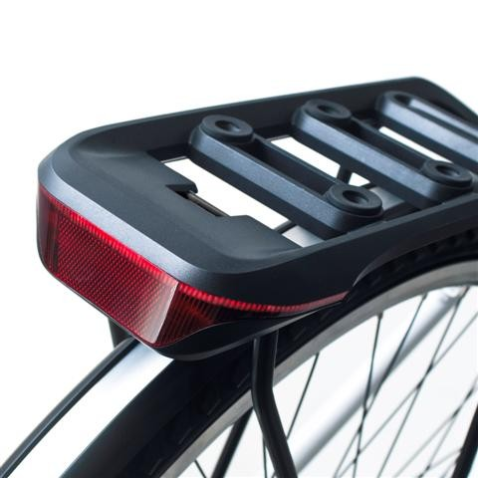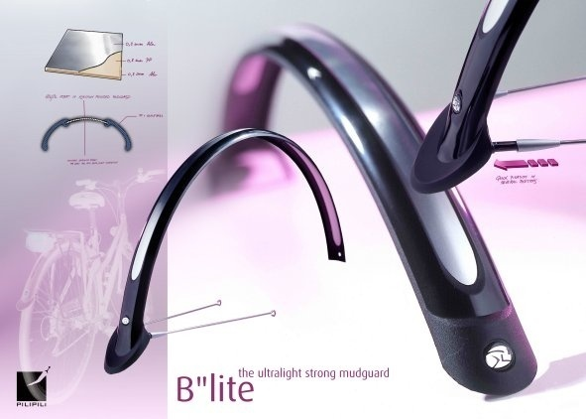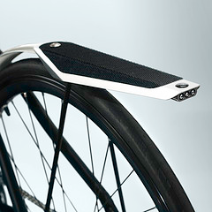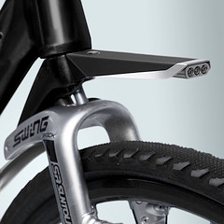

Source: Company documents.

EXHIBIT 2: Design and Innovation Awards Earned by Curana

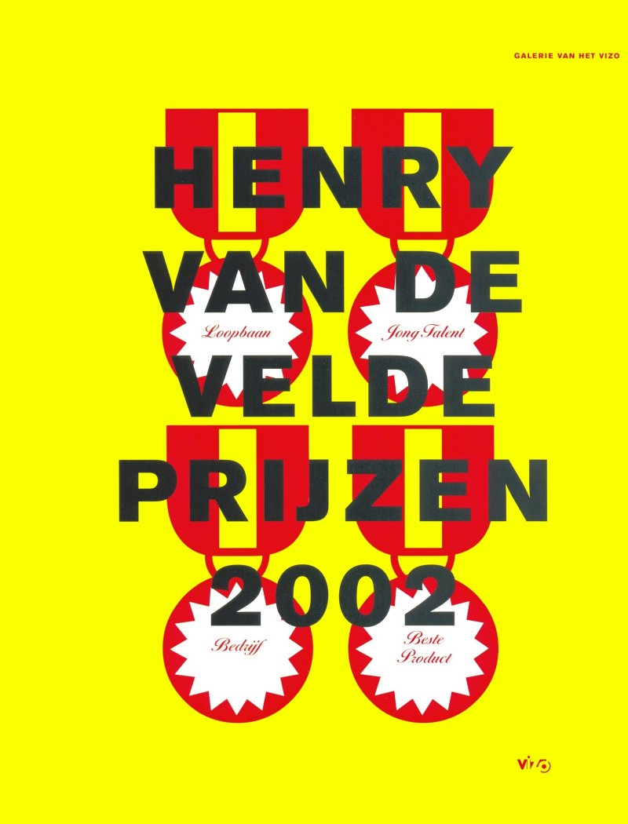

Source: Company documents.

EXHIBIT 3: The 4-step design process at Curana, 2009



Source: Company documents.

**EXHIBIT 4: CURANA’S TURNOVER AND PROFITS**

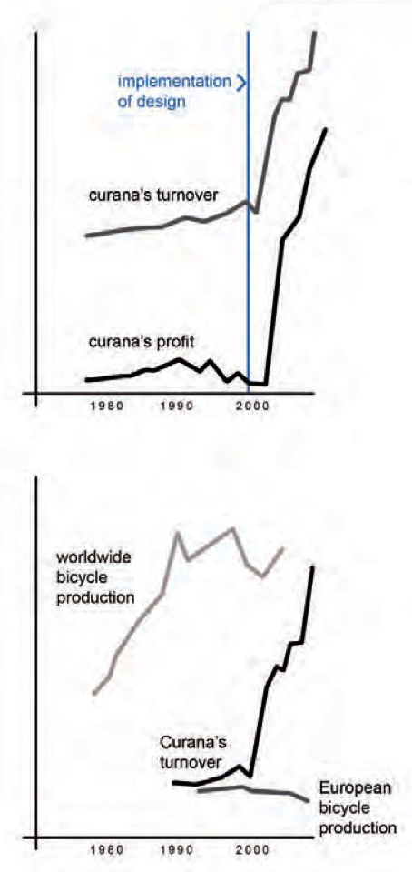

Source: Company documents.

1. Mudguards made from steel and aluminum required more steps in manufacturing and were more expensive when manufactured in high labour-cost countries.
2. € = EUR = euro; all currency amounts are in EUR unless otherwise specified.
3. Vlaams Kunststofcentrum (VKC) was a Flemish centre for plastic processing. VKC supported plastic processing companies in technical matters such as injection moulding, extrusion technologies, and thermoforming. VKC also worked for raw material producers, machine suppliers, and mould makers. A second focus of activities was advanced training.
4. “About Us: Awards,” Curana, accessed March 29, 2017, www.curana.com/index.php/what_we_do/who_is_curana/awards.